THE GUARDIAN

David Wood: 'children's theatre is the most important theatre'
As his Olivier-nominated The Tiger Who Came to Tea roars back into the West End, the playwright and director on the 'other' Matilda and why failure is not an option in children's plays
- Lyn Gardner

- theguardian.com, Thursday 3 July 2014 12.36 BST

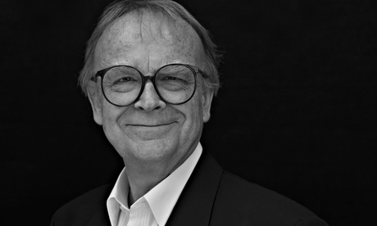
'I'm always thinking of the children' … David Wood
David Wood is used to people asking him if he is jealous of the success of Matilda and Charlie and the Chocolate Factory in the West End. Before the arrival of those mega-musicals, Wood was the premier page-to-stage adapter of the novels of Roald Dahl, with seven under his belt including very successful versions of The Witches (which gave magic consultant Paul Kieve one of his early jobs long before Harry Potter), The BFG and James and the Giant Peach.
Long before Dennis Kelly and Tim Minchin teamed up for Matilda, Wood had a stab at transferring the story of Dahl's super-intelligent poppet with kinetic powers to the stage with musical duo George Stiles and Anthony Drewe of Betty Blue Eyes and Mary Poppins fame. It didn't work out, but Wood has no regrets. He hasn't even seen Matilda, although he did slip in to see Charlie, and wasn't entirely impressed by everything he saw. But jealous? He shakes his head.
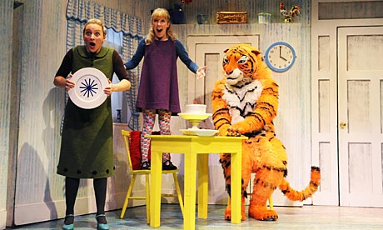'At heart I'm an entertainer': Wood's adaptation of The Tiger Who Came To Tea. Photograph: Tristram Kenton
"Of course not. I do what I do, and they are doing something completely different. I may be seen as very old-fashioned, but when I write or adapt I'm always thinking of the children. I don't think what the grownups might want. I don't see that as my job," says Wood, whose Olivier-nominated adaptation of Judith Kerr's classic picture book, The Tiger Who Came to Tea, returns to the West End this week for another summer season. It's a show that really has been a roaring success. "Even now when I watch it, I have a silly grin on my face," Wood confesses. "It's got all the things children love in stories: animals, food and a touch of magic or the surreal." They are clearly the things that Wood also loves. He may have recently turned 70, but there's a still a touch of the overgrown schoolboy about him.
Putting children first has sustained Wood over a long career that saw him turn his back on acting (early appearances included roles in Lindsay Anderson's If… and Aces High, a movie inspired by RC Sherriff's Journey's End, as well as playing Bingo in Andrew Lloyd Webber and Alan Ayckbourn's ill-fated musical, Jeeves) and instead co-found the children's theatre company Whirligig in the 1970s. He's written numerous original plays for children including The Gingerbread Man, which is still regularly performed across the world. Simon Stephens may be big in Germany, but so is David Wood.
He accepts that in some ways he has always been unfashionable ("I've never been part of the children's theatre establishment"), neither part of the theatre in education movement of the 1970s and 80s or the more innovative practice of today developed by companies such as Oily Cart, Theatre-Rites and Travelling Light. He admires what others do, but it's not what he wants to do, preferring instead to bring great classics to the stage such as Tom's Midnight Garden. "At heart I'm an entertainer," he says. Nothing wrong in that.
Although he himself has done well out of adaptations, arguing that a good story is a good story in any medium, he regrets the fact that so much of children's and family theatre is based on well-known titles. "There are too few producers who are as interested in what's on stage as they are in bums on seats," he says, "and there is a problem when the artistic content is secondary to the title." But Wood believes that schools and parents can be very conservative too: "Call something The Wind in the Willows, and do it with three actors and a ferret, and they will come."
A BBC interviewer once asked him live on air if he had "sacrificed his career for children". It's those kind of attitudes that make him angry and has led to his role as chair of Action for Children's Arts, which has lobbied for more widespread recognition of Article 31 of the UN Convention on the Rights of the Child, which states: "Every child has the right to rest and leisure, to engage in play and recreational activities appropriate to the age of the child and to participate freely in cultural life and the arts."
"It makes me annoyed when people see children's theatre as being second division," says Wood. "Children's theatre is the most important theatre, and I don't buy it's important because it's an investment in the audiences for the future argument. I don't see it as my role to prepare Cameron Mackintosh's audiences of tomorrow. It's for now. They deserve it now. We need to be giving children great theatre now, because it's such a great trigger for the imagination."
There is certainly much more family-friendly theatre touring all over the country and even taking up residence in the West End. Sally Cookson's production of Jacqueline Wilson's Hetty Feather, The Elephantom at the National Theatre and Michael Morpurgo's I Believe in Unicorns will all be joining Tiger in the West End this summer. Wood thinks it's a good thing, but says that quantity is no substitute for quality.
"In theatre people talk about the right to fail. If you work at the Royal Court maybe you have that right. But not if you work with children. Some children and families will be coming for the very first time, and if you fail it could be the last time they ever come to the theatre. I take that responsibility very seriously."
• The Tiger Who Came to Tea runs until 7 September. Box office: 0844 412 4661. Venue: Lyric theatre Shaftesbury Avenue, London, W1.

